

|  |
| --- |
| Housing Dataset |
|  |
| July 29  Sangeetha E  B3MAY(ONLINE)  60524OLE004 |



# INTRODUCTION

## A housing dataset contains detailed information about real estate properties, typically including features such as property size, location, number of rooms, age, and sale prices. This dataset is crucial for analyzing market trends, predicting property values, and understanding factors influencing real estate prices. It often includes demographic data, historical sales, and economic indicators to provide a comprehensive view of the housing market. By leveraging this data, stakeholders can make informed decisions regarding property investments, pricing strategies, and market analysis, ultimately enhancing their ability to navigate and capitalize on real estate opportunities.

AIM

## The aim of a housing dataset is to provide comprehensive, accurate, and actionable information about real estate properties. It seeks to facilitate the analysis of market trends, property valuations, and factors influencing real estate prices. By integrating diverse data points, such as property features, geographic location, and historical sales, the dataset supports predictive modeling and trend analysis. This enables stakeholders—such as real estate agents, investors, and analysts—to make informed decisions, optimize pricing strategies, and identify investment opportunities. Ultimately, the dataset aims to enhance strategic planning and decision-making in the real estate market.

Top of Form

## **Top of Form**

## **Bottom of FormBUSINESS PROBLEM/PROBLEM STATEMENT**

In the real estate industry, accurate and comprehensive housing datasets are crucial for understanding market trends, pricing strategies, and investment opportunities. A common business problem arises when housing datasets are fragmented, outdated, or incomplete, making it difficult to perform reliable market analysis and forecasts. For example, a real estate firm might struggle with integrating data from various sources, leading to inconsistencies in property valuations, neighborhood trends, and demographic insights. This issue hampers the ability to provide clients with accurate recommendations and can result in missed investment opportunities. The problem statement, therefore, is: “The current fragmentation and inconsistency in our housing dataset hinder effective market analysis and strategic decision-making, affecting our ability to provide accurate property valuations and investment advice. We need a unified, updated, and comprehensive dataset to enhance data-driven insights and support better business outcomes.”

# Project Workflow

# A housing dataflow project workflow outlines the systematic approach to managing, processing, and analyzing housing data from collection to actionable insights. Here’s a structured workflow:

# Data Collection: Gather housing data from diverse sources, such as real estate listings, public records, and market reports. Ensure data is relevant, accurate, and comprehensive.

# Data Integration: Combine data from various sources into a unified system or database. This step involves cleaning and harmonizing data formats to ensure consistency.

# Data Cleaning and Transformation: Address missing values, outliers, and inconsistencies. Transform data into a usable format by normalizing, aggregating, and enriching it as needed.

# Data Storage: Store the cleaned and transformed data in a secure and scalable storage solution, such as a relational database or a data warehouse.

# Data Analysis: Perform exploratory data analysis (EDA) to identify trends, patterns, and insights. Use statisticamethods and data visualization tools to understand market dynamics.

# Model Building: Develop predictive models or algorithms to forecast housing trends, pricing, and other key metrics. Validate and refine models to improve accuracy.

# Reporting and Visualization: Create dashboards and reports to present findings. Use visualization tools to convey insights clearly to stakeholders.

# Decision Making: Utilize insights from analysis and models to make informed business decisions, such as pricing strategies, investment opportunities, or market expansion.

# Monitoring and Feedback: Continuously monitor the performance of data models and workflows. Gatherfeedback from users to improve data quality and system efficiency

# Iteration and Improvement: Regularly update data sources, refine models, and enhance processes based on new information and evolving business needs.

# This workflow ensures a structured approach to handling housing data, leading to actionable insights and better decision-making.

# Data Understanding

# Data Understanding is a critical phase in working with a housing dataset, focusing on comprehending the data’s nature, quality, and relevance to the project's objectives. This stage involves several key activities:

# Data Exploration: Begin by examining the dataset's structure, including the types of variables (e.g., numerical, categorical) and their distributions. Look at summary statistics, such as mean, median, and standard deviation, to understand the central tendencies and variability of the data.

# Data Quality Assessment: Identify and assess issues related to data quality, such as missing values, duplicates, inconsistencies, and outliers. Determine the impact of these issues on analysis and plan remediation strategies.

# Contextual Analysis: Understand the context in which the data was collected, including the geographic and temporal scope. For housing data, this might involve understanding local market conditions, property types, and economic factors influencing the data.

# Feature Analysis: Investigate individual features to understand their relevance and relationships with other variables. For instance, examine how factors like location, size, and amenities correlate with property prices.

# Data Distribution: Analyze the distribution of key variables to identify patterns and trends. Visualization tools such as histograms, scatter plots, and box plots can help reveal insights about the data’s distribution and relationships.

# Stakeholder Input: Engage with stakeholders to ensure the data meets their needs and to clarify any additional requirements or objectives.

# Understanding these aspects of the housing dataset provides a foundation for effective data processing, analysis, and ultimately, making informed business decisions

Data Cleaning -Missing Values Imputation, Outliers, Handling Inconsistent Value

Data Cleaning is essential for ensuring the accuracy and reliability of a housing dataset. This process addresses missing values, outliers, and inconsistent values to prepare the data for meaningful analysis. Here’s how to handle each aspect:

1. Missing Values Imputation:
   * Identification: Detect missing values in the dataset using methods like checking for nulls or NaNs.
   * Imputation Strategies:
     + Mean/Median Imputation: Replace missing numerical values with the mean or median of the column.
     + Mode Imputation: For categorical variables, use the most frequent category.
     + Predictive Imputation: Use algorithms like k-Nearest Neighbors (k-NN) or regression models to predict and fill missing values.
     + Deletion: Remove rows or columns with excessive missing values if imputation is not feasible.
2. Handling Outliers:
   * Detection: Identify outliers using statistical methods like Z-scores or IQR (Interquartile Range). Visualize data using box plots or scatter plots.
   * Treatment:
     + Transformation: Apply transformations like logarithms or square roots to reduce the impact of outliers.
     + Capping: Use techniques like Winsorization to limit extreme values to a certain range.
     + Removal: If outliers are due to errors or irrelevant, consider removing them from the dataset.
3. Handling Inconsistent Values:
   * Standardization: Ensure consistent formatting for categorical values (e.g., standardize addresses or property types).
   * Correction: Rectify discrepancies by cross-referencing with authoritative sources or correcting typographical errors.
   * Validation: Use domain knowledge to validate the consistency of data entries, such as checking for logical errors (e.g., negative property sizes).

Effective data cleaning improves the quality and usability of the dataset, paving the way for accurate analysis and reliable insights.

MISSING VALUE

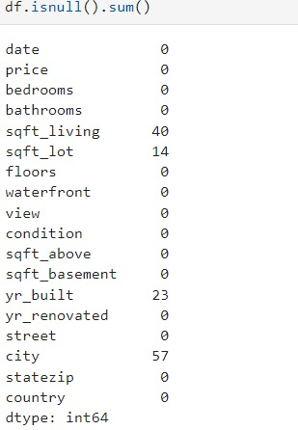

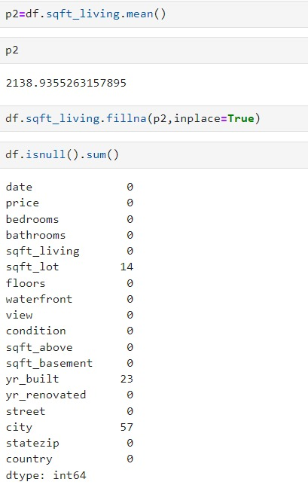

Handling outlier

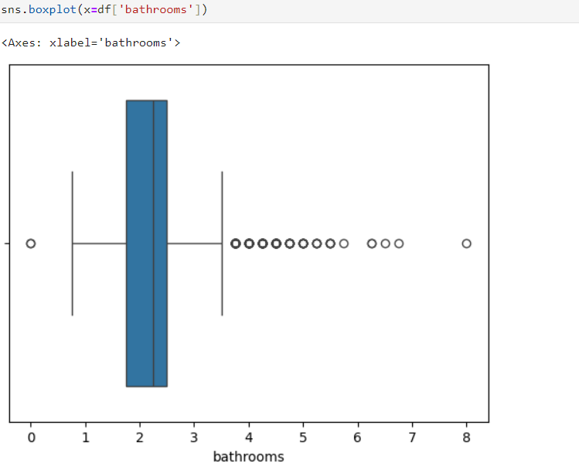

Obtaining Derived Metrics

Obtaining derived metrics from a housing dataset involves calculating new variables that provide deeper insights into property values and market trends. Key derived metrics include:

1. Price per Square Foot: Calculate by dividing the property price by its size. This metric helps compare property values on a per-unit basis.
2. Rental Yield: Derived from the annual rental income divided by the property price, indicating the potential return on investment.
3. Price Growth Rate: Measure the percentage change in property prices over time to assess market trends.
4. Median Home Price: Calculate the median value of homes in a given area to understand typical property values.
5. Days on Market: Compute the average time properties stay listed before being sold, reflecting market demand and property desirability.
6. Affordability Index: Combine property prices with local income data to evaluate housing affordability in different regions.

These metrics offer valuable insights for market analysis, investment decisions, and pricing strategies.

a=file.corr()

plt.figure(figsize=(9,9))

sns.heatmap(a,annot=True,cmap="Blue")

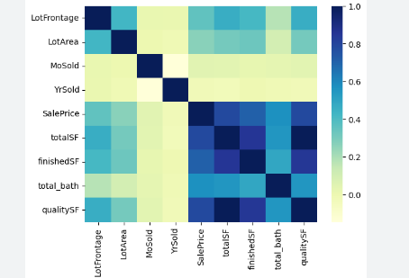

Filtering Data And Analysis

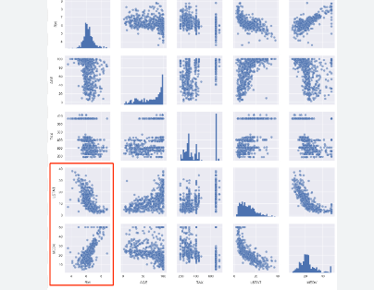

To filter and analyze a housing dataset, follow these steps:

1. Load Data: Import the dataset using pandas (e.g., pd.read_csv).
2. Explore Data: Check the structure with df.head() and df.describe().
3. Filter Data: Apply conditions, such as df[(df['Price'] >= 100000) & (df['Price'] <= 500000)] for price range.
4. Clean Data: Handle missing values and remove duplicates with dropna() and drop_duplicates().
5. Analyze: Use descriptive statistics, correlations (df.corr()), and visualizations (e.g., histograms, scatter plots) to gain insights.

Adjust filtering and analysis based on specific goals and dataset features

EDA -Univariate Analysis

In univariate analysis of a housing dataset, the focus is on examining each variable individually to understand its distribution, central tendency, and variability. For numerical variables like price, square_footage, or number_of_bedrooms, you might use summary statistics such as mean, median, and standard deviation to grasp their typical values and spread. Histograms and box plots can visually depict distributions, revealing patterns such as skewness or outliers.

For categorical variables like location, type_of_property, or condition, frequency counts and bar charts are useful to see the most common categories and their proportions. This can highlight trends, such as a high frequency of houses in urban areas or a common property type.

Overall, univariate analysis helps in identifying the characteristics and anomalies of individual variables, setting the stage for more complex exploratory data analysis. By understanding each feature in isolation, you can better prepare for multivariate analysis and predictive modeling.

SEGMENTED UNIVARIATE ANALYSIS

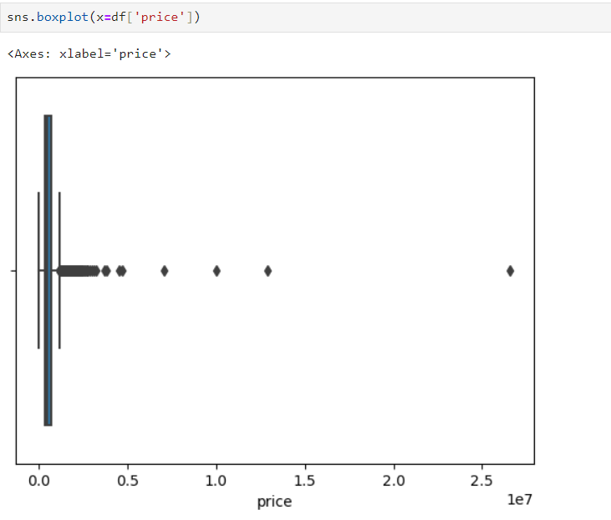

In segmented univariate analysis of a housing dataset, you examine variables within distinct subgroups to uncover nuanced patterns. For instance, if analyzing price, segment the data by categories such as location or property_type. Calculate summary statistics like mean and median for each segment to compare how prices vary between urban and suburban areas, or between different property types.

Histograms and box plots within each segment can highlight variations in distribution, central tendency, and outliers across groups. For categorical variables, use frequency counts and bar charts to compare the prevalence of categories within segments.

This approach reveals how relationships and distributions differ across segments, providing deeper insights into how factors such as location or property type influence housing characteristics. It helps tailor strategies or models to specific subgroups, improving overall data understanding and decision-making.

Top of Form

Bottom of Form

Top of Form

Bottom of Form

Bivariate Analysis

Bivariate analysis examines the relationship between two variables to uncover patterns, trends, or associations. In a housing dataset, common variables include property prices, square footage, number of bedrooms, and location. For instance, analyzing the relationship between square footage and property prices can reveal whether larger homes generally command higher prices. A scatter plot can visually demonstrate this correlation, often showing a positive trend: as square footage increases, so does the price.

Another important bivariate analysis could be between the number of bedrooms and the property price. This might also show a positive relationship, indicating that more bedrooms typically correlate with higher prices. Additionally, exploring the interaction between location and price can provide insights into geographic trends. For example, properties in urban areas may have higher prices compared to those in suburban or rural locations.

By using statistical methods such as correlation coefficients or regression analysis, one can quantify these relationships, providing a clearer understanding of how different variables interact in the housing market. This analysis is crucial for buyers, sellers, and real estate professionals to make informed decisions and identify key factors influencing property values

Multivariate Analysis

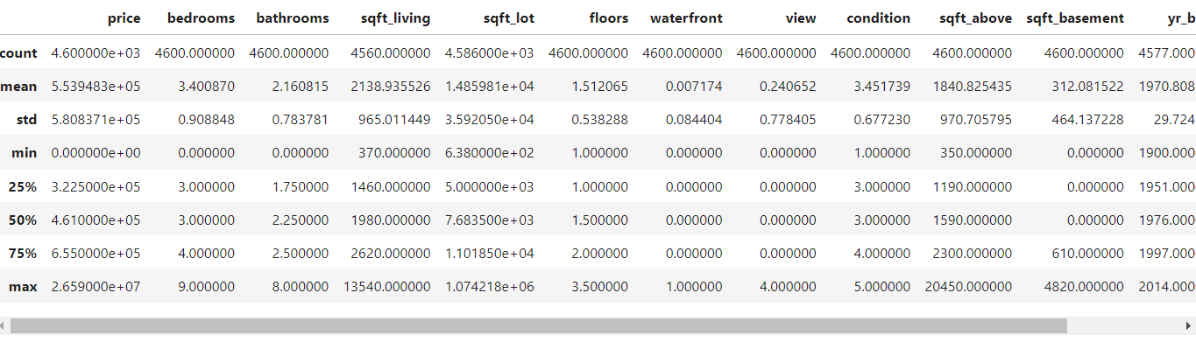

Multivariate analysis extends the examination of relationships to more than two variables, offering a deeper insight into complex datasets like those found in housing markets. In such a dataset, variables might include property price, square footage, number of bedrooms, neighborhood, and age of the property.

One common technique is multiple regression analysis, which assesses how several independent variables (e.g., square footage, number of bedrooms) simultaneously influence a dependent variable (e.g., property price). This approach helps isolate the effect of each variable while controlling for the influence of others. For example, it can reveal whether the impact of additional square footage on price is consistent regardless of the number of bedrooms.

Another useful method is principal component analysis (PCA), which reduces the dimensionality of the dataset while preserving variance. PCA can identify underlying factors, such as general property quality or desirability, that drive variations in property prices across different features.

Multivariate analysis can also include cluster analysis to group similar properties based on multiple attributes. This helps in identifying distinct market segments, such as luxury homes versus affordable housing, and tailoring strategies accordingly.

Overall, these techniques provide a comprehensive view of how various factors interact and contribute to property values, aiding in more nuanced decision-making and strategy development in real estate.

Overall Insights Obtained from Analysis

Analyzing a housing dataset yields valuable insights that can significantly impact real estate decisions, investment strategies, and market understanding. Key findings from a comprehensive analysis typically include:

1. Price Determinants: Through bivariate and multivariate analyses, it's often observed that property prices are strongly influenced by factors such as square footage, number of bedrooms, and location. Larger homes and those with more bedrooms usually command higher prices. Location, too, plays a critical role, with properties in desirable urban or well-established neighborhoods often fetching higher prices compared to those in less sought-after areas.
2. Geographic Trends: Analysis frequently reveals geographic trends where urban areas exhibit higher property values due to proximity to amenities, employment centers, and better infrastructure. Suburban and rural areas, while generally lower in price, may show different growth patterns or offer better value propositions for certain buyer segments.
3. Market Segmentation: Cluster analysis can identify distinct market segments, such as luxury homes versus affordable housing. This segmentation helps in tailoring marketing strategies and understanding the specific needs and preferences of different buyer groups.
4. Property Features and Value: Multiple regression models often show how different features contribute to overall property value. For example, a newly renovated home may see a higher price uplift compared to an older property, even if the square footage and number of bedrooms are similar.
5. Investment Opportunities: Insights into variables such as property age and condition can highlight areas with potential for value appreciation. Properties in emerging neighborhoods or those needing renovation but priced lower might present attractive investment opportunities.
6. Market Dynamics: Understanding the interaction between various factors helps in forecasting market trends and pricing strategies. For instance, a combination of increasing square footage and desirable location may indicate rising property values.

Overall, these insights are crucial for making informed decisions in buying, selling, and investing in real estate, allowing stakeholders to navigate the housing market effectively and capitalize on opportunities.

Top of Form

Bottom of Form

Top of Form

Conclusion

In conclusion, the analysis of a housing dataset provides critical insights into the factors driving property values, such as square footage, number of bedrooms, and location. It highlights geographic trends and market segments, revealing how these elements interact to influence pricing. By identifying key determinants and investment opportunities, stakeholders can make informed decisions, tailor strategies, and forecast market trends more accurately. Understanding these dynamics equips buyers, sellers, and investors with the knowledge needed to navigate the housing market effectively and capitalize on emerging opportunities. Overall, a comprehensive analysis is essential for strategic planning in real estate.

Top of Form

Bottom of Form

Bottom of Form